Children’s Liturgy
Create a Prayer Space
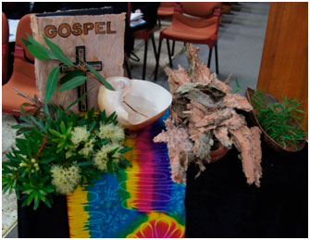

A cloth in brown or red to symbolise the earth/Aboriginal material in brown or earthy colours.
Old shoes/footprints/decorated thongs with Aboriginal symbols
Bible
Candle
Aboriginal symbols provided by your local Aboriginal Catholic Ministry or group (Didgeridoo, Coolamon, clapsticks)
Prayers
Creator God, we come together today. We thank you for the ……………………………peoples who treasured and cared for the land we stand on. We pray for them and we pray for us.
Holy Ground
The land we stand on is holy ground. It’s holy ground because we stand with each other.
Its holy ground because we are made in the image of God.
It’s holy ground because God loves each of us and God invites us to see each other as the likeness of God.
Together
We pray that we can stand together.
We pray that we can walk together
Help us to share our gifts with each other
Help us to listen to each other
Give us courage to walk with each other

God of all people
Let us pray
God of all people, your son, Jesus was rejected and forced to leave his own land.
We ask you to give us strength to walk with all our brothers and sisters, willingness to work together to be reconciled and courage to listen with an open heart and mind so that our sacred land of Australia, will be a place where everyone is welcomed, respected and celebrated.
We make this prayer in Jesus’ name
Amen
Gospel Commentary
In the Gospel, Jesus is not accepted in his own land. People he grew up with rejected Him. We all know what it’s like to be rejected. In the past, some people would say to people to walk a mile in my shoes. Imagine walking in the shoes of your parents, or your grandparents or your cousins or your next door neighbour. Our shoes, if they could talk, would tell lots of stories of where we have been, the people we met, how fast we travelled, what the road or footpath or the ground we travelled on was like.
Questions for Students
Today we think about Aboriginal and Torres Strait Islander people. What type of journey have they walked? How have they walked on this land? An Indigenous person could tell a story of one of their journeys or explain how Aboriginal people showed their journeys through their art.
Do we know what it’s like to walk in someone else’s shoes?
What sort of footprint do we leave behind? Is it one of respect, love, kindness or is it deep and destructive, heavy with hate?

ACTIVITIES
We All Stand on Sacred Ground Activity
The land is very important to Aboriginal and Torres Strait Islander people. They have a strong spiritual and cultural links to the land and have walked upon and cared for it for thousands of years.
Create your own prayer space:
- Decorate footprints or old shoes for the prayer space
- Trace your own footprints and write in the space We All Stand on Sacred Ground
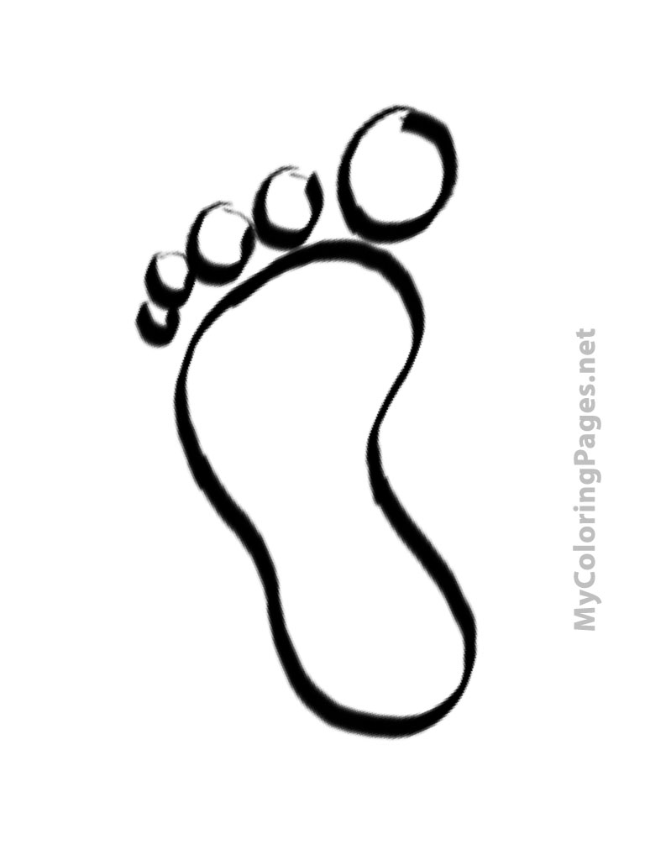

Story Sharing
Paint, draw or write a story about what you think is holy ground/ or a symbol of your own footprint/how do Aboriginal and Torres Strait Islander people walk in love? What symbols do they use?
Make a word cloud –
Write a prayer about being accepted and accepting of all people. Pick out the most important and used words by the class or group and arrange them on a page to form a word cloud.
Example
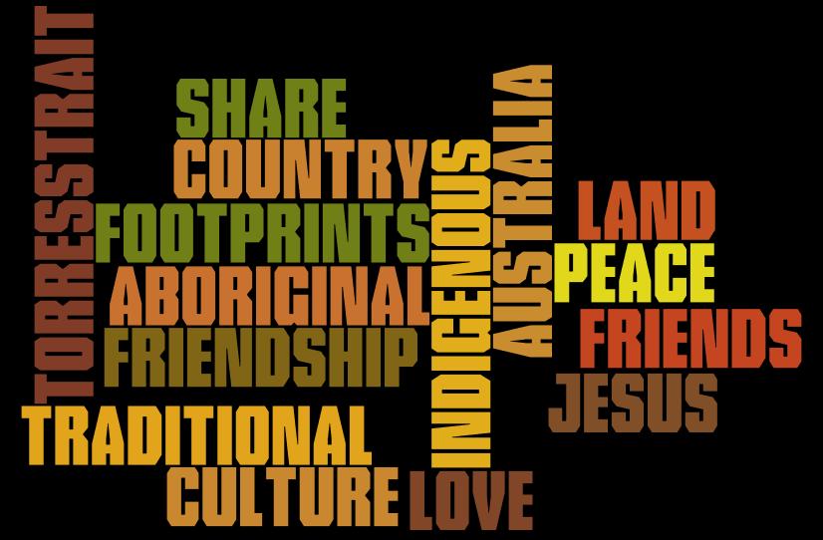

Faith Stones
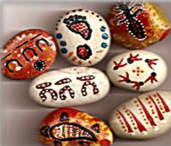
Each stone is unique and they are an excellent medium to show that although they are different, they are all important and precious in God’s eyes. It would be terrific if an Aboriginal person could be invited to lead the group in painting.
Students should be encouraged to use thought and imagination in depicting their faith through painting the rock.
Whilst the stones are drying, encourage students to talk about what they painted and how there are similarities and differences in each painting.
Once finished, they could be arranged in your prayer space or classroom.
Materials:
Stones (palm sized) - smooth and clean, any shape, 1 per student. River pebbles are ideal.
Acrylic paints
Brushes Newspapers Shirts, smocks, or aprons
Felt and glue
Newspaper or material to protect tables and floor
Before class:
Wash stones and ensure that they are dry.
Setup painting stations
Faith Connection
Faith Connection St. Peter wrote about Jesus in the Bible as the “living stone” who was rejected by the people in power but approved and precious in God’s eyes. We, too, are “living stones” (1 Peter 2:4–5). We are God’s building stones of the Church, with Jesus as the cornerstone. God wants to build Church with you and me. Let the stones with our names on them remind us of all the saints who have lived before us. We, too, should strive to become good and loving persons.

Learning about Saints
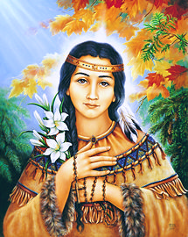
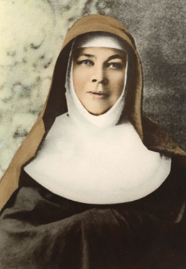

Students might learn about Saints that are linked in some way with sharing, kindness and inclusion.
The Saints below are linked with Aboriginal and Torres Strait Islands. St. Kateri is a Native American Saint and Sr. Mary MacKillop is the first Australian Saint.
St. Kateri Tekakwitha
St. Kateri Takakwitha is the patron saint of the environment. She is the first Native American saint. She was born in 1656 to the daughter of a Mohawk warrior and a Catholic Alqonquin. Father Jacques de Lambertville, a Jesuit missionary baptized her. She was devoted to prayer and penitenial practices. She also cared for the sick and aged. At the age of four her mother and brother died of smallpox. Kateri's face was scarred by the disease and she became almost blind. St. Kateri died during Holy Week. Within 15 minutes of death her face was healed of its scars. She appeared to many people after her death, always carrying a cross. We celebrate St. Kateri's feast day on July 14.
Saint Mary MacKillop
Saint Mary MacKillop is one of the most remarkable and inspiring women that Australia has produced. She dedicated her life to the Sisters of St Joseph, the first religious order to be founded by an Australian, and in doing so, Saint Mary MacKillop provided an outstanding example that we as a society can follow.
Despite a vow of poverty and a dependence on Divine Providence, Saint Mary managed to make education available to the poor and the marginalised people of rural Australia.
Even when faced with challenging times, Saint Mary refused to attack those who wrongly accused her and undermined her work. She continued in the way that she believed God was calling her, and was always ready to forgive those who wronged her.
Saint Mary showed compassion for anyone in need, regardless of race, colour or faith, and a reverence for the dignity of others, especially those most neglected in society.

