**Introduction**

The National Aboriginal and Torres Strait Islander Catholic Council (NATSICC) represents Indigenous Catholics in Australia. The culture, circumstances and the variety of ways that our people celebrate the Word of the Lord form a 'patchwork' of beauty and diversity, NATSICC wants to highlight and promote these gifts as they that add colour and 'texture' to the Church - serving to open her doors further to people of all backgrounds.

The theme of the resource this year is "Peace and Mercy for all" and they include a range of Ceremonies, rituals and prayers that may be utilised where approved and appropriate. NATSICC advises that you consult your parish Priest or pastoral council when preparing your Mass. When using traditional ceremonies, it is imperative that local Indigenous community is consulted. A list of State and Territory Aboriginal and Islander Catholic Ministries (AICMs) are can be found at www.natsicc.org.au in the 'Your NATSICC' section. The simple effort of making contact with your local Aboriginal and Torres Strait Islander Catholic congregation is an act of respect, reconciliation and will build bridges of communication.

The 2013 resources are our most extensive, particularly with the inclusion of the Small Group Activity sessions. These activities assist and encourage small groups of Catholics to sit and reflect on scripture in the context of Aboriginal and Torres Strait Islander Catholics. The resources give Parish and School groups the opportunity to meet several times throughout the year as well as invite Indigenous Catholics to participate in the discussions.

Young people are the future of the Catholic Church. The Youth activities are an effective way of engaging young people in a way that is enjoyable. Extra copies of the puzzles and activities are also available at the NATSICC website.

NASTICC hopes that Aboriginal and Torres Strait Islander Sunday is celebrated in all Parishes and Catholic Schools across the country. We welcome any photos, stories or articles of how the day was celebrated in your area.

*Deep down, we Aborigines are religious people. We did not have many material goods, but we are rich with spiritual goods. It is this strong religious side that made us. It gave us our identity, our dignity, our self-assurance. My People existed here in Australia thousands of years before Abraham, In all that time, God was with my people. He worked through their culture. He was saving us despite human weakness. He was preparing us for the day we would see the features of Aborigines in the image of His Son.*

*Deacon Boniface Perdjert, Wadeye (Port Keats,NT)*

Traditional Ceremonies*

*The following ceremonies enrich the community and should involve local Aboriginal and Torres Strait Islander Catholics. Working together with Indigenous members of your community is an opportunity to share, listen and discuss faith and culture and is a form of 'Practical Reconciliation'.*

# A Rite of Water Blessing

Lord, make us feel your invitation to ‘come to the water’. At the very beginning you blessed the water, your great gift to us, and now we ask that your blessing be renewed in this water here today. We ask that through this water blessing we will all be renewed with your love, and protection, and your power to love one another as true Christians. Lord, this truly is a sign of the new life in Christ, which in Baptism we have all received. We ask this prayer through Christ our lord. Amen.

# It is customary in some areas, when Aboriginal people gather for important ceremonies to use water. Water containers can be a large shell or coolamon and a small branch from an appropriate native tree can be used to sprinkle the water. Please collaborate with your local Aboriginal and Torres Strait Islander group to ensure this rite of water blessing is appropriate.

Water to Aboriginal people is always a sign of God’s peace and fulfillment in everything that is good; the promise of food, of harmony with ourselves, and the bush around us.

**A Rite of Smoking**

This is traditionally celebrated by Aboriginal people. Since the beginning of time our ancestors used to smoke away evil spirits and receive the good spirit. We acknowledge Aboriginal Elders to lead Smoking Ceremony. Today we share with you one of the oldest living ceremonies, to remove our sins and ask for forgiveness. We invite you now to share our smoking ceremony like our ancestors have done for thousands of years.

Fire is important to Aboriginal people and is the heart of Indigenous culture. It is the sign of the Holy Spirit that gives warmth, purifies, and brings many gifts

**Involving your local Aboriginal or Islander Catholic Ministry (AICM)**

Visit www.natsicc.org.au and go to 'Your NATSICC' and click on your State or Territory to find your local AICM. These ministries work very hard to serve local Indigenous Catholics and do much good in the community. You may be able to work together in preparing the Liturgy, sourcing speakers or presenters or learning more about Aboriginal and Torres Strait Islander Catholics in your area.

Whilst Aboriginal and Torres Strait Islander Sunday is on the first Sunday of July each year, we ask that you keep your Indigenous brothers and sisters in your heart and mind all year.

**\* These Ceremonies can be used prior or following Mass or, where appropriate, during other gatherings to Celebrate Aboriginal and Torres Strait Islander Sunday**

**Liturgy Resources**

**Welcome**

Today is Aboriginal and Torres Strait Islander Sunday. It is also the beginning of a week of celebrations throughout the nation where Aboriginal and Torres Strait Islander people celebrate their spirituality, identity, culture and survival.

Aboriginal and Torres Strait Islander Catholics bring beautiful gifts to the Church in Australia, and it is on this day that we celebrate those gifts. The Theme NATSICC has chosen is "Peace and Mercy for All".

A Welcome to Country by an Aboriginal Elder

**ALTERNATE** Acknowledgement of Country by Celebrant in the Introductory Rite.

Hymns & Acclamations

**Entrance Processional**

May be accompanied by a Didgeridoo

**Entrance Hymn:** Blest be the Lord AOV 179 or GA 458

**Mass setting:**  Local choice

**Gospel Acclamation:**  “Alleluia” as per local choice

**Aboriginal Our Father**: If appropriate. Contact your local Catholic Aboriginal Community.

**Communion Hymn:**  One Bread One Body (AOV 129 or GA 193), Communion Song (AOV1 87)

**Recessional Hymn:** City of God AOV 57or GA 498

**Recessional**

May be accompanied by the Didgeridoo. Aboriginal Elders join if applicable.

**Liturgy of the Word**

**First Reading:** Is 66:10-14

Rejoice, Jerusalem,

be glad for her, all you who love her!

Rejoice, rejoice for her,

all you who mourned her!

That you may be suckled, filled,

from her consoling breast,

that you may savour with delight

her glorious breasts.

For thus says the Lord:

Now towards her I send flowing

peace, like a river,

and like a stream in spate

the glory of the nations.

At her breast will her nurslings be carried

and fondled in her lap.

Like a son comforted by his mother

will I comfort you.

And by Jerusalem. you will be comforted.

At the sight your heart will rejoice,

and your bones flourish like the grass.

To his servants the Lord will reveal his hand.

This is the word of the Lord.

**Responsorial Psalm:** Ps 65:1-7, 16.20. R. v. 1

**R** *Let all the earth cry out to God with joy.*

1 Cry out with joy to God all the earth,

O sing to the glory of his name .

O render him glorious praise.

Say to God: 'How tremendous your deeds! **R**

2 'Before you all the earth shall bow;

shall sing to you, sing to your name!'

Come and see the works of God,

tremendous his deeds among men. **R**

3 He turned the sea into dry land,

they passed through the river dry-shod.

Let our joy then be in him;

he rules for ever by his might. **R**

4 Come and hear, all who fear God.

I will tell what he did for my soul.

Blessed be God who did not reject my prayer

nor withhold his love from me. **R**

**Second Reading:** Gal 6:14-18

The only thing I can boast about is the cross of our Lord Jesus Christ, through whom the world is crucified to me, and I to the world. It does not matter if a person is circumcised or not; what matters is for him to become an altogether new creature. Peace and mercy to all who follow this rule, who form the Israel of God. I want no more trouble from anybody after this; the marks on mybody are those of Jesus. The grace of our Lord Jesus Christ be with your spirit, my brothers. Amen.

The word of the Lord.

**Gospel Acclamation:**

Alleluia, alleluia!

May the peace of Christ rule in your hearts,

and the fullness of his message live ,within you.

Alleluia!

**Gospel Procession**

In the spirit of our ancestors the Message Stick can be carried forward (and upright) with the Gospel Book. It should be held upright during the Gospel reading. There are other symbols and actions that can be used according to local sacred tradition and need to be discussed according to local practice.

**GOSPEL:** Lk 10:1-12,17-20

The Lord appointed seventy-two others and sent them out ahead of him, in pairs, to all the towns and places he himself was to visit. to house. He said to them, 'The harvest is rich but the labourers are few, so ask the Lord of the harvest to send labourers to his harvest. Start off now, but remember, I am sending you out like lambs among wolves. Carry no purse, no haversack, no sandals. Salute no one on the road.

Whatever house you go into, let your first words be, "Peace to this house!" And if a man of peace lives there, your peace will go and rest on him; if not, it will come back to you. Stay in the same house, taking what food and' drink they have to offer, for the labourer deserves his wages; do not move from house to house. Whenever you go into a town where they make you welcome, eat what is set before you. Cure those in it who are sick, and say, "The kingdom of God is very near to you." But whenever you enter a town and they do not make you welcome, go out into its streets and say, "We wipe off the very dust of your town that clings to our feet, and leave it with you: Yet be sure of this: the kingdom of God' is very near." I tell you, that on that day it will not go as hard with Sodom as with that town.'

The seventy-two came back rejoicing. 'Lord: they said 'even the devils submit to us when we use your name.' He said to them, 'I watched Satan fall like lightning from heaven. Yes, I have given you power to tread underfoot serpents and scorpions and the whole strength of the enemy; nothing shall ever hurt you. Yet do not rejoice that the spirits submit to you; rejoice rather that your names are written in heaven.

The Gospel of the Lord.

MCj04160140000[1]**Prayers of the Faithful**

Please select the intentions for your community from the following:

**Celebrant:** On this day of celebration as we acknowledge the Aboriginal and Torres Strait Islander peoples throughout Australia, we turn to God in prayer and seek the help of the Holy Spirit as we commit ourselves to praying and journeying together in a spirit of Reconciliation.

**Reader:** We pray for the Church, Pope Francis, the Bishops, Priests, Deacons religious and laity: that they  
joyfully follow in your footsteps with the guidance of the Holy Spirit. Let us pray to the Lord:

**All:** Lord, hear our prayer

**Reader:** We pray for all leaders of political parties: that their decisions be guided by compassion and acceptance of all peoples, and that they be open to the Holy Spirit in their minds and heart to make the right choices for all. Let us pray to the Lord:

**All:** Lord, hear our prayer

**Reader:** We pray for all Aboriginal and Torres Strait Islander Communities: that the Holy Spirit strengthen the love of Jesus in our lives, as they struggle for truth, equality, justice and healing. Let us pray to the Lord:

**All:** Lord, hear our prayer

**Reader:** We pray for our Brothers and Sisters who struggle for Justice and Reconciliation: that they will be blessed by God's love. Let us pray to the Lord:

**All:** Lord, hear our prayer

**Reader:** We pray for our Brothers and Sisters who have turned away from their Faith, that the Holy Spirit guide them on the right path back to the Church and the sacraments. Let us pray to the Lord:

**All:** Lord, hear our prayer

**Reader:** We pray for our young people: that the Holy Spirit, and the Blessed Virgin Mary will walk with them and touch their lives as they make their contribution to God, the Church and society. Let us pray to the Lord:

**All:** Lord, hear our prayer

**Reader:** We pray for the sick and dying, the homeless and imprisoned, the refugees in detention, the weary and lost: that their Faith stay strong, and that the Blessed Mother Mary's love of all fill their hearts. Let us pray to the Lord:

**All:** Lord, hear our prayer

**Reader:** We pray that our Faith stays strong and continues to what God's wants it to be in Australia. Let us pray to the Lord:

**All:** Lord, hear our prayer

**Celebrant:** We pray, Almighty God, as your people and seek the power of your Holy Spirit. We bring our needs before you in trust and confidence. We ask these prayers through Christ our Lord. Amen.

**Presentation of the Offerings**

In some areas the coolamon is used to carry the bread to the altar. In the absence of Aboriginal and Torres Strait Islander people participating in the celebration, a coolamon can be placed in front of the Sanctuary as a symbol of the non-presence of Aboriginal and Torres Strait Islander brothers and sisters at the table.

(Alternative/additional Aboriginal gifts: a boomerang, woomera, Aboriginal painting, clap sticks … )

# Additional Prayer Suggestions

**Holy Father, God of Love**

Holy Father, God of Love, You are the Creator of this land and of all good things.

Our hope is in you because you gave your son Jesus to reconcile the world to you.

We pray for your strength and grace to forgive, accept and love one another, as you love us and forgive and accept us in the sacrifice of your son. We ask this through Christ our Lord.

Amen

(Prepared by Wontulp Bi – Buya Indigenous Theology Working Group)

**God of the Holy Dreaming**

God of holy Dreaming

Great Creator Spirit

From the dawn of creation you have given your children

The good things of Mother Earth

You spoke and the gum tree grew

In the vast deserts and dense forests, in the cities,

At the water's edge, creation sings your praise.

Your presence endures as the rock at the heart of our land.

When Jesus hung on the tree

You heard the cries of all Your people

And became one with Your wounded ones

The convicts, the hunted and the dispossessed.

The sunrise of Your Son

Coloured the earth anew

And bathed it in glorious hope.

In Jesus we have been reconciled to You,

To each other and to Your whole creation.

Lead us on Great Spirit

As we gather at this special place

Located on land where ancestors of long ago

Gathered for work, play and praise.

Enable us to walk together in trust from the hurt of the past

Into the full day which has dawned in Jesus Christ.

Amen.

**Prayer for Special People**

Father, Our Creator

You created all things seen and unseen

Listen to my silent prayers as I stand here before you

As my weary eyes look back over distant horizons,

Back to those days where my people walked.

The footprints of my Grandfathers are imprinted on the earth,

And the images become real to me.

I see my Grandfathers standing tall and strong,

Warriors of long ago.

I hear them singing.

I see them dancing,

And my Spirit moves within me.

They told of the emus fighting,

And the kangaroos picking up the scent or our hunters.

The images fade away as I feel the hurt of my people.

I can hear the cries of my Grandmothers as they cry for their children.

Grandfather, you can see me as I stand here and feel this hurt.

Father Creator, is this the purpose of my being here.

Or is it your plan to reshape my people

To be once again the proud race it once was?

Let me walk with you and my Grandfathers

Towards the dawning of a proud and new nation.

I thank you for my Sacred Being.

**Reconciliation Prayer**

Holy Father, God of Love

You are the Creator of this land and all good things

We acknowledge the pain and shame of our history

And the suffering of our peoples.

And we ask your forgiveness.

We thank you for the survival of Indigenous cultures

Our hope is in you because you gave your son Jesus

To reconcile the world to you.

We pray for your strength and grace to forgive,

Accept and love one another,

As you love us and forgive and accept us

In the sacrifice of your Son.

Give us the courage to accept the realities of our history

So that we may build a better future for our nation.

Teach us to respect all cultures.

Teach us to care for our land and waters.

Help us to share justly the resources of this land.

Help us to bring about spiritual and social change

To improve the quality of life for all groups in our communities,

Especially the disadvantaged.

Help our young people to find true dignity and self esteem by your Spirit

May your power and love be the foundations

on which we build our families, our communities and our Nation.

Through Jesus Christ our Lord.

Amen

**Prayer of the Aboriginal People** (where an Indigenous reader is available)

Father of all, you gave us the Dreaming. You have spoken to us through our beliefs. You then made you love clear to us in the person of Jesus. We thank you for your care. You own us, you are our hope. Make us grow strong as we face the problems of change. We ask you to help the people of Australia to listen to us and respect our culture. Make the knowledge of you grow strong in all people, so that you can be at home in us and we can make a home for everyone in our land. Amen.

**Aboriginal Lord’s Prayer** (where approved and an Indigenous reader is available)

You are our Father, You live in Heaven

We talk to You, Father, You are good.

We believe Your Word, Father, we Your children.

Give us bread today.

We have done wrong, we are sorry.

Help us Father, not to sin again.

Others have done wrong, to us

And we are sorry for them, Father today.

Stop us from doing wrong, Father.

Save us all from the evil one.

You are our Father, You live in Heaven.

We talk to You, Father, You are good.

**Clip Art**

Artist: Melissa Brickell

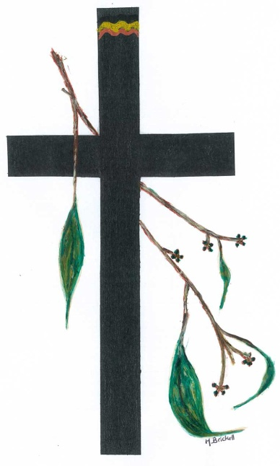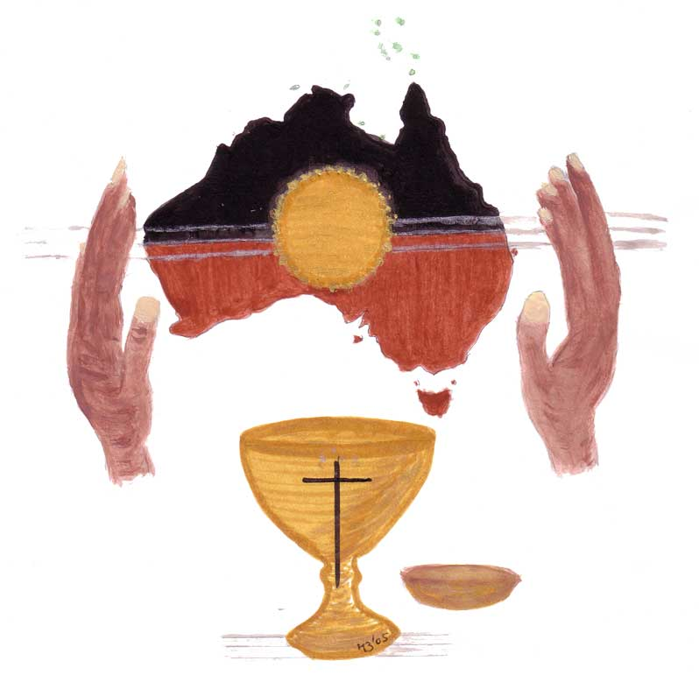

Artists: Kimberly Clip Art

